Macintosh HD:Users:karola2:Desktop:mx:PRESSE allg.:Logos:msctt-logo_f.eps 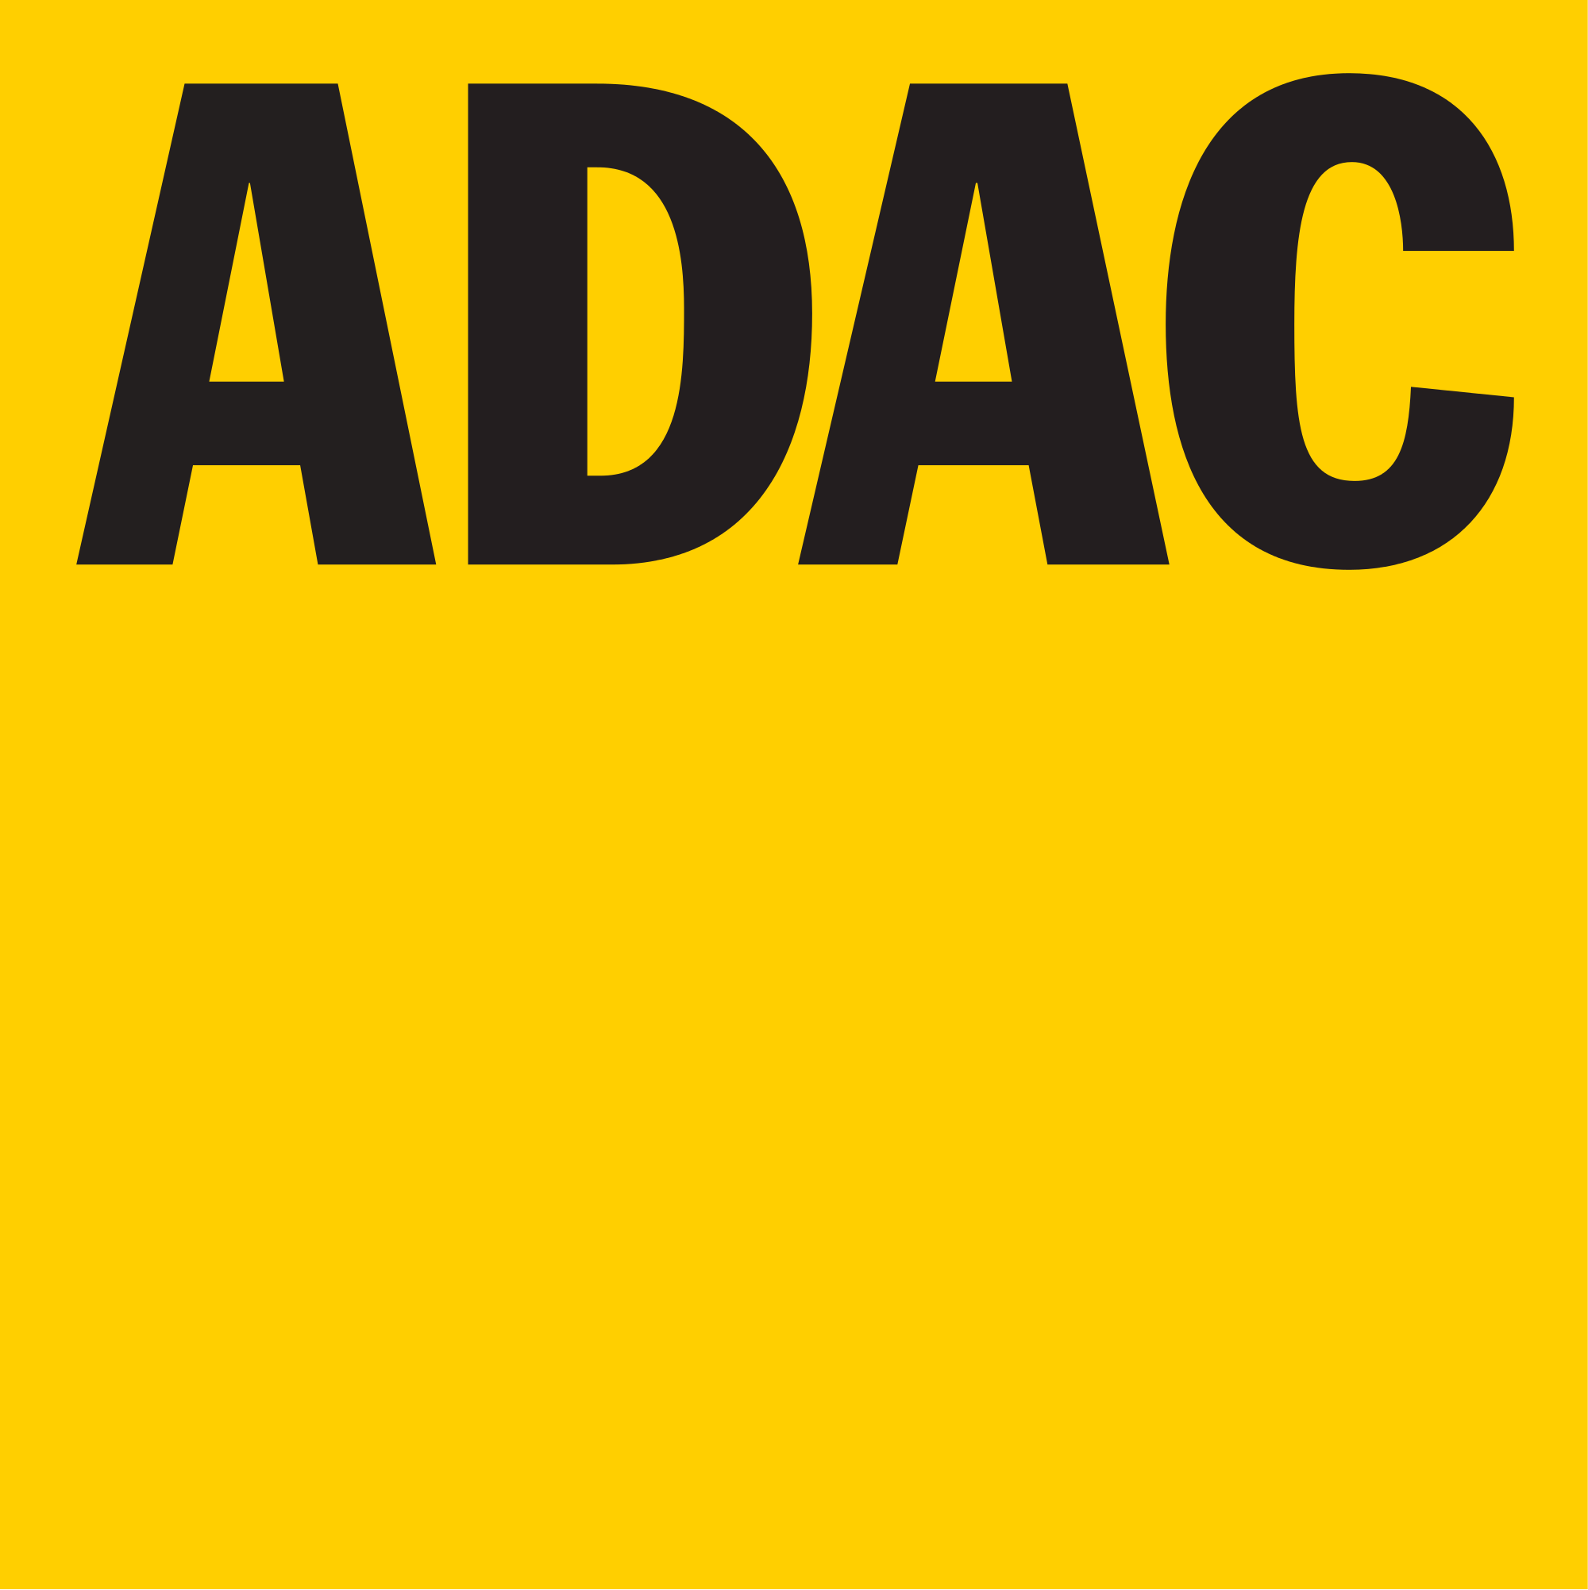

83. ADAC-MOTOCROSS TEUTSCHENTHAL

14. - 15.09.2019

|  |  |  |  |  |  |  |  |
| --- | --- | --- | --- | --- | --- | --- | --- |
| **STARTERLISTE Kl. 5 / MX1** Stand: 13.09.2019 | | | | | | | |
|  | **Nr.** | **Vorname** | **Name** | **Wohnort** | **Fahrzeug** | **Team** | **Ortsclub** |
|  | 3 | Nico | Silber | Roßleben | Honda |  |  |
|  | 4 | Hardy | Schadenberg | Magdeburg | Kawasaki | MX Team Schadenberg | MC Motor Mitte Magdeburg |
|  | 20 | Christian | Tietz | Linthe | KTM | KTM GST BERLIN RACING |  |
|  | 21 | Pit | Falke | Magdeburg | Kawasaki | Motorradsport Straub | MC Motor Mitte Magdeburg |
|  | 24 | Norbert | Schulze | Potsdam | Kawasaki |  |  |
|  | 29 | Ivo | Braunschweig | Zerben | Suzuki |  |  |
|  | 36 | Max | Stein | Querfurt | KTM | MX-Team Naumann |  |
|  | 45 | Philipp | Kühne | Bad Düben | Yamaha | TYK - Team Yamaha Knobloch |  |
|  | 60 | Stephan | Mock | Wolfsburg | Suzuki | Team Motorrad Waldmann |  |
|  | 72 | Nik | Wachtel | Halle/Saale | Yamaha | TYK - Team Yamaha Knobloch | MSC Teutschenthal e.V. |
|  | 106 | Christoph | Baierl | Anderbeck | Suzuki | H & K Motorsport SUZUKI MOTO CREW | MC Westerhausen |
|  | 109 | Dirk | Cieslik | Magdeburg | Kawasaki | MX Team Schadenberg | MC Motor Mitte Magdeburg |
|  | 133 | Toni | Gottfried | Neu-Bensdorf | KAWASAKI |  | MSC Schollene e.V. im DMV |
|  | 171 | Tiemo | Stibbe | Tangermünde | Husqvarna | MX-Team Naumann | MC Billberge |
|  | 269 | Marin | Noller | Gaildorf | KTM |  |  |
|  | 273 | Patrick | Böhm | Stendal OT Jarchau | Suzuki | MOHAAK RACING TEAM | MSC Altmark e.V. |
|  | 412 | Kris | Kaltenbrunn | Sassenburg | Kawasaki | Team Popko Kawasaki | MSC Letzlingen |
|  | 529 | Marcel | Tuch | Brandenburg/  Havel | Husqvarna | MOHAAK RACING TEAM | MSC Altmark e.V. |
|  | 711 | Luca | Lier | Lengede | Kawasaki | Team Popko Kawasaki | MSV Dolle e.V. im ADAC |
|  | 859 | Vincent | Peter | Berlin | KTM | Kosak Racing Team |  |
|  | 976 | Marian | Fober | Magdeburg | Husqvarna | MOWIK RACING | MSV Dolle e.V. im ADAC |